EXP NO – 15
TRANSACTION LEVEL MODELING (TLM) USING SYSTEMC

AIM
To model and simulate Transaction Level Modeling (TLM) using SystemC, demonstrating communication between an initiator and a target through high-level transactions instead of signal-level communication.

PROGRAM
#include <systemc>
#include <tlm>
#include <tlm_utils/simple_initiator_socket.h>
#include <tlm_utils/simple_target_socket.h>

using namespace sc_core;
using namespace tlm;
using namespace std;

struct Target : sc_module
{
tlm_utils::simple_target_socket<Target> socket;

SC_CTOR(Target) : socket("socket")
{
socket.register_b_transport(this, &Target::b_transport);
}

void b_transport(tlm_generic_payload &trans, sc_time &delay)
{
int *data;

data = (int*)trans.get_data_ptr();

cout << "Target Received Data = "
<< *data
<< " at "
<< sc_time_stamp()
<< endl;

delay += sc_time(10, SC_NS);
}
};

struct Initiator : sc_module
{
tlm_utils::simple_initiator_socket<Initiator> socket;

SC_CTOR(Initiator)
{
SC_THREAD(process);
}

void process()
{
tlm_generic_payload trans;

int data = 100;

trans.set_command(TLM_WRITE_COMMAND);
trans.set_address(0);
trans.set_data_ptr((unsigned char*)&data);
trans.set_data_length(sizeof(data));

sc_time delay = SC_ZERO_TIME;

cout << "Initiator Sending Data = "
<< data
<< endl;

socket->b_transport(trans, delay);

wait(delay);

cout << "Transaction Completed at "
<< sc_time_stamp()
<< endl;
}
};

SC_MODULE(Top)
{
Initiator initiator;
Target target;

SC_CTOR(Top)
: initiator("Initiator"),
target("Target")
{
initiator.socket.bind(target.socket);
}
};

int sc_main(int argc, char* argv[])
{
Top top("Top");

sc_start();

return 0;
}

SIMULATION

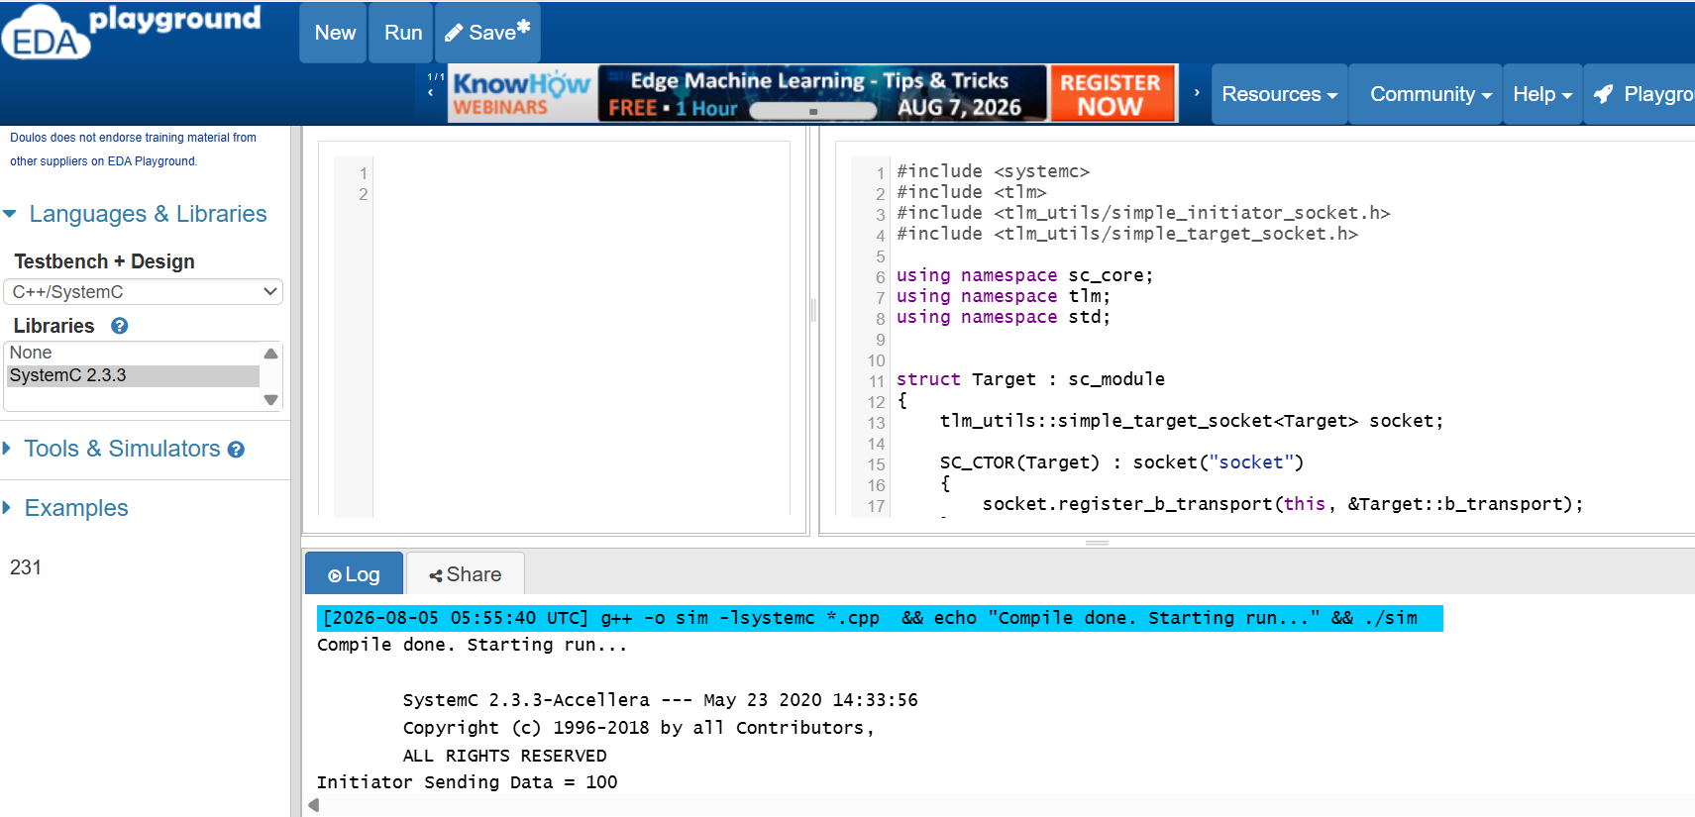

OUTPUT :

